How to Disconnect the Polycom Units and Connect a DTEN Zoom Unity

- Before unboxing the DTEN unit. Verify that the name on the videophone matches the name written on the DTEN box. Below you can see the two different units deployed throughout the State and where to find the units name.
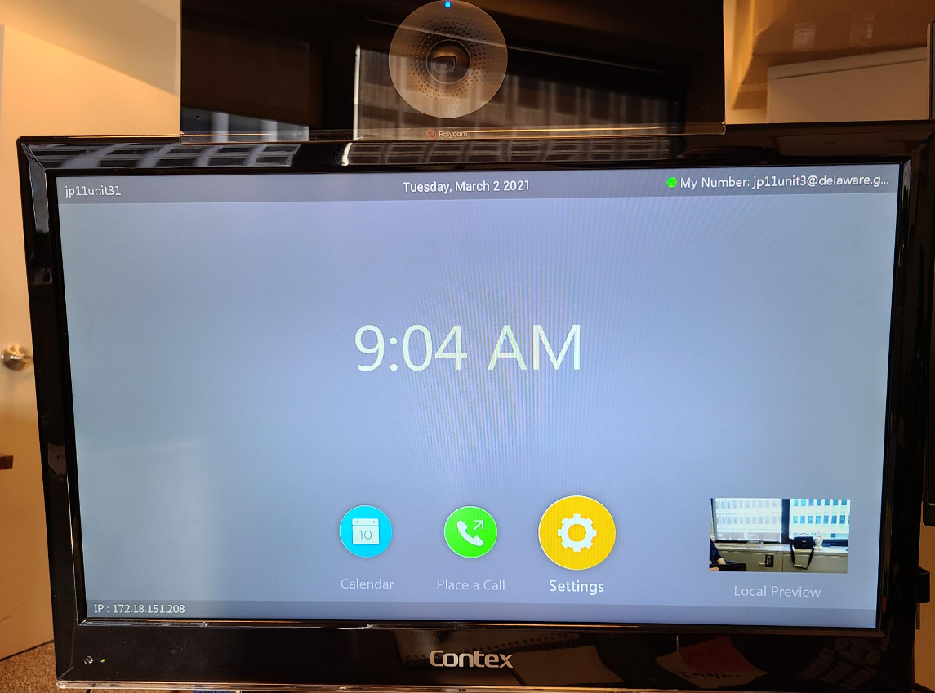
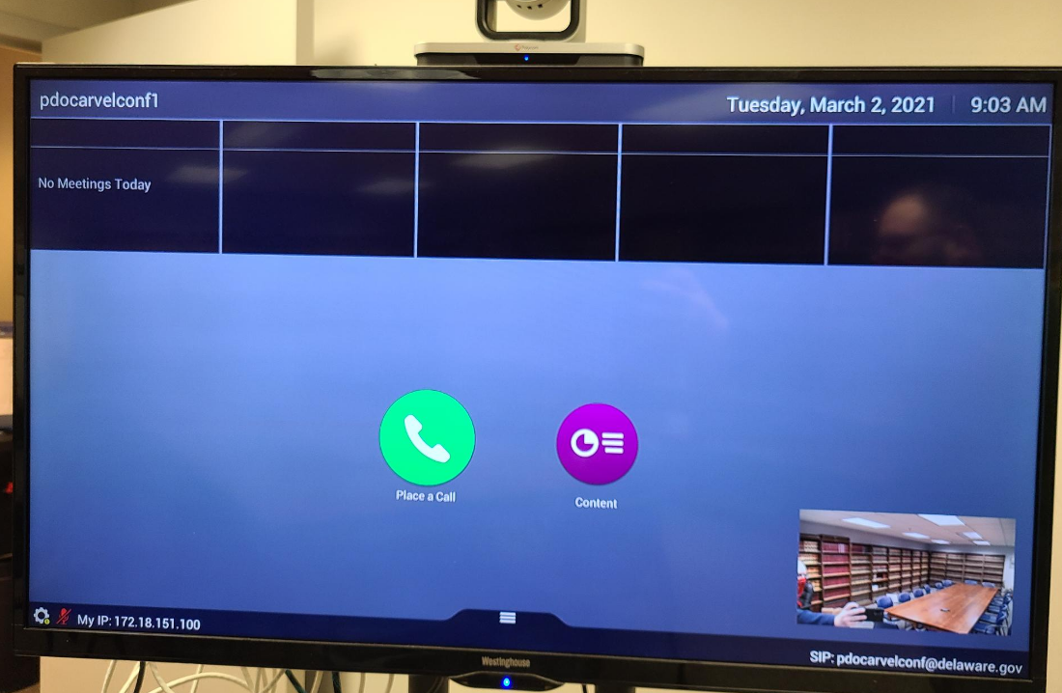

- Once you have verified that you have the correct unit, it is time to disconnect the old Polycom system. You will either have a Polycom Debut or a Polycom 310 unit. A Debut unit sits on top of the TV or is mounted to the wall. The 310 unit is a silver box that sits below the monitor.

- Debut
- Go to the back of the unit. You will notice that there is an ethernet cable, HDMI cable, and a power cord. We only need the ethernet cable for the DTEN unit. Disconnect the ethernet cord (highlighted in photo) and place it to the side. Now, disconnect the TV, HDMI cable, power cable, and the Debut unit and place it in a secure location until CJC techs can pick them up.
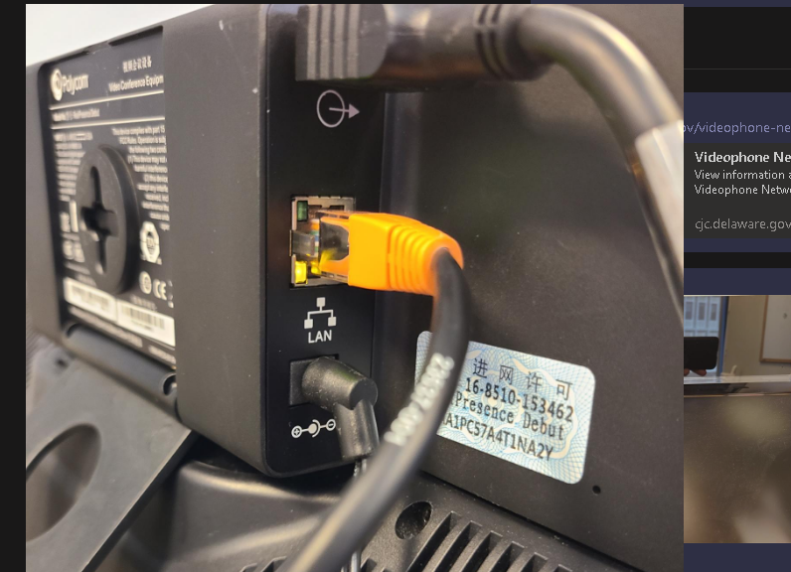
- Now that you have the old Polycom unit disconnected and cleared out of the way. Unbox the DTEN unit and set in place of the Polycom unit. Once in place, there is a small tab in the back of the unit. Using your finger, pry the tab up to display the ethernet port. Once exposed, connect the ethernet cable you disconnected from the Polycom unit to this port. Now, connect the power adapter that is supplied in the DTEN box and connect to the unit. Once connected, the unit will power on. See directions attached on how to use the unit.
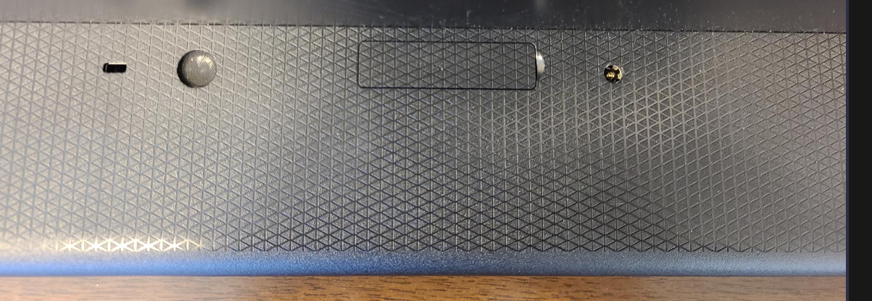
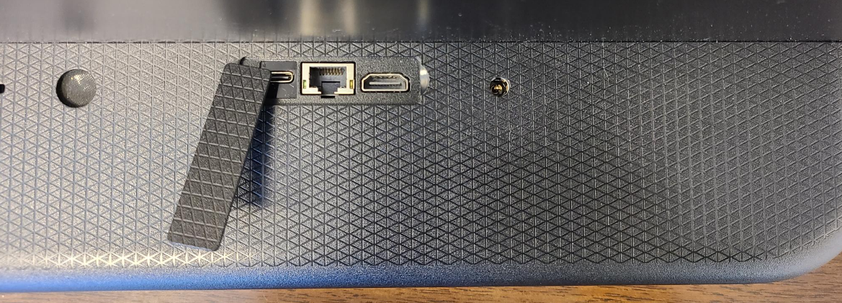
Ethernet
Power Cable

- Polycom 310
- Locate the 310 unit and go to the back of the unit. You will notice that there is a camera connected, microphone, HDMI cable, ethernet, and a power cable. We only need the ethernet cable for the DTEN setup, disconnect this and place to the side. Now disconnect the TV, camera, microphone, HDMI cable, power cable and place in a secure location until a CJC tech can pick up.
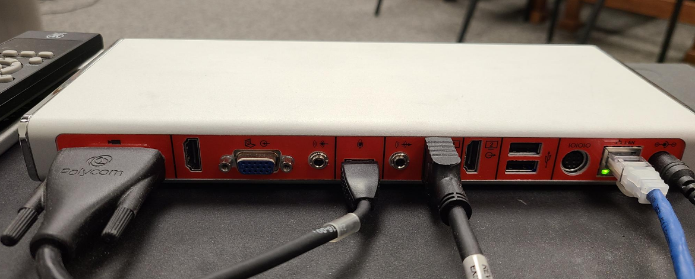

- Now go to #2 under Debut setup and follow the directions on connecting a DTEN unit.
Video instructions available online at https://cjc.delaware.gov/videophone-network/

